**St. Francis Institute of Technology**

Department of Information Technology

Mini Project –Web Based Business Model (ITM 501)

# Fitness Maniac

**TEITA-4**

Soumadeep Das – 55

Rahul avhad - 57

Nathan Vaz – 62

Justin madhri – 64

Mentor:

Priya Maam

Associate Professor

## Overview

* Business Model Canvas
* Customer segment
* Customer relationships
* Channels
* Key partners
* Key activities
* Key resources
* Revenue
* Cost
* Value Proposition
* Initial system design
* Updates system design
* References

## Brands



## Customer Segment

• Mass Market

Our aim is to reach each and every age group a provide them our good quality fitness products.

## Customer Relationships

• Customer satisfaction is our main goal in which we try to give customer best products and service .



### Channels

● Supplements

-Supplements and fitnessequipments(clothing,footwear etc) will be available throughout the online store 24X7

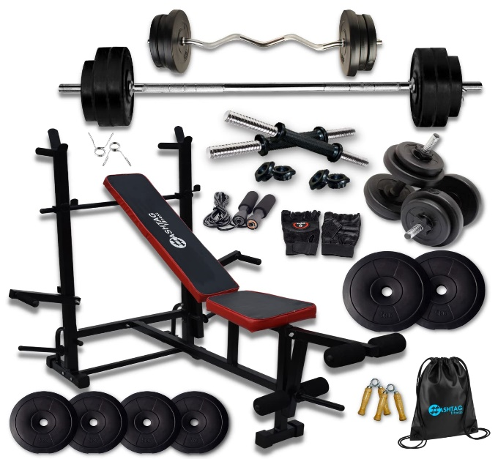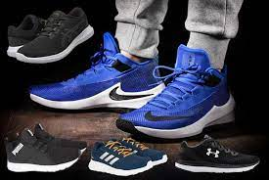

## Key Partner

● Supplements stores

- For all the supplements for the buying

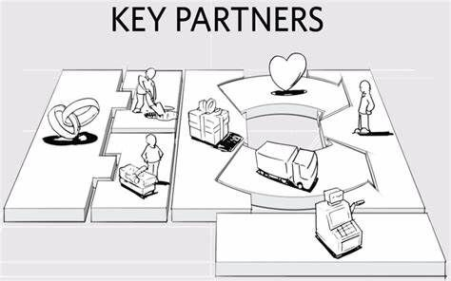

● Equipment stores

- For all the equipment for the buying

### Key Activities

* Nutrition supplements selling online
* Clothings and footwear for Men/Women
* Selling basic home workout equipments.

## Revenue

* Supplements purchase commission
* Clothing&footwear purchase commission
* Equipments purchase commission



## Cost

● Variable Cost

* Domestic charges
* long delivery charges
* Utility expenses

## Value Proposition

* Delivery
* convenience
* rewards and benefits
* Accessibilities
* suppliers

**Initial system design**

## Updated system design

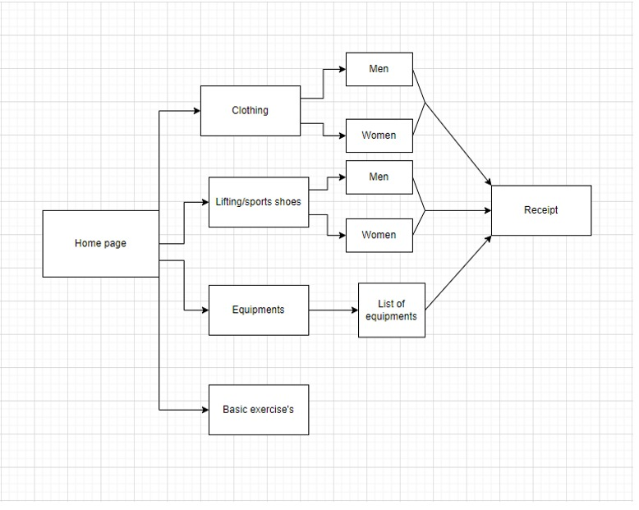

Reference